Online GISc course
Using Excel for GIS analysis
The online one (1) day GISc course will provide participants with the knowledge to use Excel to analyse and map spatial trends. Data with location (latitude and longitude, geographical names, kml and shapefiles) will be used in the analysis process.
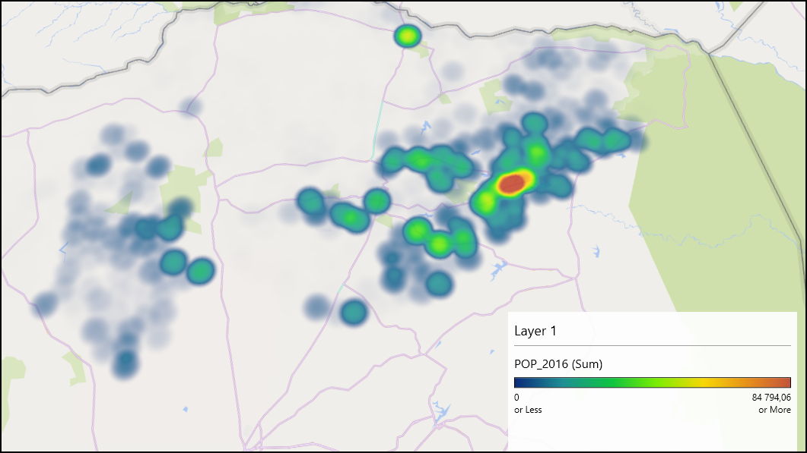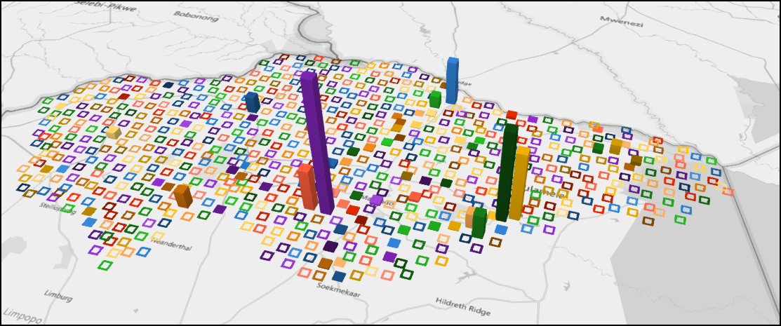
Course program
- Course outlay.
- Important GISc concepts.
- Excel introduction.
- Prepare and discuss databases for analysis.
- Excel analysis and mapping.
Costing
Costing for the course will apply a tier mechanism to calculate the cost of attending the training:
- Tier 1 will include training and training material. Cost = R750 per day.
- Tier 2 will include training, training material and one (1) hours of consultation after the training is completed. Cost = R1 000 per day.
- Tier 3 will include training, training material and two (2) hours of consultation after the training is completed. Cost = R1 800 per day.
The consultation will be for six months after the completion of the course. Other consultations can be booked here.
Date
The course will take place from 24 June 2021.
Booking
Please book here:
Here

